

**Easy Hotel Management System Requirements Specification**

**Version 2.0**

**May 11, 2019**

Prepared by: Accepted by: Dr. Igli Hakrama

Jona Cara

Halisa Quku

Fiori Fizi

Shejla Domnori

Valentina Roçi

Jorid Spaha

# Software Analysis and Design

## User Scenarios

|  |  |  |
| --- | --- | --- |
| **Number** | **User Scenario** | **Description** |
| **1** | Admin logins into the system | Admin user insert his/her own credentials (username/email and password) to login into the system |
| **2** | Admin fails to login into the system | Admin provides wrong username/email or password thus the login will fail |
| **3** | Admin changes his/her credentials | Admin changes his/her stored information on the system (email, username, password etc.) |
| **4** | Admin logs out of the system | Admin clicks the logout button to initiate logout process. Then the home page will be displayed |
| **5** | Admin views room details of the system | Admin can check all room details that exist on the system including their number, price, type etc. |
| **6** | Admin adds new room to the system | Admin can add new rooms on the system by providing room number, price, type and other specification |
| **7** | Admin modifies room properties | Admin can modify room specification if there is such a need |
| **8** | Admin deletes room from the system | Admin can delete room from the system. He will be demanded to confirm the removal process if he/she clicks the delete room button. |
| **9** | Admin views staff/employee details | Admin can view all the details defined on the system for the registered staff/employee |
| **10** | Admin adds new staff/employee to the system | Admin can add new employee on the system. She/he will enter her/his information and give the login credentials to the new registered staff for her/his account |
| **11** | Admin modifies staff/employee credentials | Admin can modify insights for the staff. Most of the time it will be the salary that the admin chooses to change. |
| **12** | Admin deletes staff/employee from the system | Admin removes an employee from the system after she/he leaves the job |
| **13** | Admin views product details | Admin can check details of the products that exists on the system. |
| **14** | Admin adds product to the inventory | Admin can add specific product to the inventory so it will be easier to keep track of the hotel’s product. |
| **15** | Admin modifies product | Admin can modify the available products. |
| **16** | Admin deletes products | Admin can delete a specific product from the system’s inventory. |
| **17** | Admin views financial report | Admin views the financial report of his/her hotel for a specific time that he/she can choose |
| **18** | Admin views guest details | Admin views the details provided by the guests that has made a reservation at his/her hotel |
| **19** | Admin views rooms availability | Admin views rooms availability at a specific time for each room |
| **20** | Admin views booking details | Admin will be notified for every new booking, booking modification and booking cancellation that will be done. |
| **21** | Admin modifies booked rooms | Admin will be notified will an email or notification changes that have to be done for a reservation. This taking into the consideration that the guest and receptionist are not available to modify it. |
| **22** | Admin views guest reviews | Admin checks reviews done from the guest after their staying in the hotel and also can leave a reply to their comments if he wants to |
| **23** | Admin prints room cleanliness status | Admin can see which of the cleanser has to clean each specific room and have a printed receipt with these information |
| **24** | Admin leaves notes for the employees | Admin can send a message to other staff members of the system for a specific reason |
| **25** | Admin assigns and controls tasks | Admin can assign different tasks related to the hotel issues which have to be done and later approved by the staff member. |
| **26** | Receptionist logs in into the system | Receptionist user insert his/her own credentials (username/email and password) to login into the system |
| **27** | Receptionist fails to login into the system | Receptionist provides wrong username/email or password thus the login will fail |
| **28** | Receptionist changes his/her credentials | Receptionist can changes his/her stored information on the system (email, username, password etc.) |
| **29** | Receptionist logs out of the system | Receptionist clicks the logout button to initiate logout process. |
| **30** | Receptionist makes a reservation | Receptionist can make a reservation to the system by entering guests credentials and clicking ‘Book’ button |
| **31** | Receptionist replies to guest messages | Receptionist gets messages of the guests in the system and replies in the real time. |
| **32** | Receptionist can check who is Checking-in/ Checking-out of the hotel. | Receptionist can view check-in/check-out, in the dashboard of the system. So he can provide specific attention to the client |
| **33** | Receptionist is notified by the system for new bookings | Receptionist assures that the booking is done correctly, by being in touch with the client |
| **34** | Receptionist views booked rooms and availability | Receptionist looks at availability in case of reservations from phone call. |
| **35** | Receptionist clicks settings | Receptionist can edit its credentials and can also upload a profile picture |
| **36** | Guest logs in the system | Guest insert his/her own credentials (username/email and password) to login into the system |
| **37** | Guest fails to login into the system | Guest provides wrong username/email or password thus the login will fail |
| **38** | Guest logs out of the system | Guest clicks the logout button to initiate logout process. Then the web page of Hotel Enera will be displayed. |
| **39** | Guest opens Profile | Guest receives a welcoming message. |
| **40** | Guest enters check-in, check-out dates and clicks ‘Check availability’ button | Guest can see room types available in the dates entered in the system |
| **41** | Guest clicks Book Now | Guest will have to fill out its credentials to make the request valid |
| **42** | Guest clicks Send Message | Guest can Contact in real time with the receptionist or manager of the hotel |
| **43** | Guest clicks setting | Guest can modify its credentials and also it can upload a picture. |
| **44** | Cleaner logs in the system | Cleaner is asked to insert his/her own credentials (username/email and password) to login into the system |
| **45** | Cleaner logs out of the system | Cleaner clicks the logout button to initiate logout process. Then the home page will be displayed |
| **46** | Cleaner views Dashboard | The information with the rooms he is assigned to clean is shown |
| **47** | Cleaner clicks setting | Cleaner can modify its credentials and also it can upload a picture. |
| **48** | Cleaner clicks tick or cross button in the rooms to be cleaned section | Cleaner changes the state of the room as clean or unclean due to certain reasons. |
| **49** | Cleaner clicks print | If there is a printer connected Cleaner can get the receipt with the information. |

### User Scenarios Extended

1. **Admin logins into the system**
2. Admin opens the login page of the system
3. Admin is asked to enter his/her credentials (username/password)
4. Admin proves that he/she is not a robot by checking the Captcha
5. Admin clicks Login button
6. If his/her credentials matches with any of the data in the current database, the admin is successfully logged in
7. Admin gets redirected to the main view (dashboard) of the web page
8. **Admin fails to login into the system**
   1. Admin opens the login page of the system
   2. Admin is asked to enter his/her credentials (username/password)
   3. Admin proves that he/she is not a robot by checking the Captcha
   4. Admin clicks Login button
   5. Admin types one of his/her credentials wrong therefore these data are not found on the database.
   6. Admin will get e message error telling him/her that he has typed wrong credentials thus he will have to try to login again
   7. Admin can click forgot password if the password is wrong or type his credentials again
9. **Admin changes his/her credentials**
   1. Admin is first logged in
   2. Admin clicks on the profile tab under settings which will open the current profile of the logged in user in this case Admin
   3. Admin can view all his/her information on this page
   4. Admin edits or changes all the information that he/she wants to modify
   5. Admin clicks Save button
   6. The changed information is stored now on database and the page is refreshed with the new entered information

1. **Admin logs out of the system**
   1. Admin is logged in
   2. Admin clicks the logout button under Settings tab
   3. Admin’s session is over, and he will be successfully logged out
   4. The system is directed to the login page
   5. If Admin wants to login again, he has to write his credentials again otherwise a successful login will not be executed.
2. **Admin views room details of the system**
   1. Admin is logged in the system
   2. Admin clicks on the settings tab in the navigation bar
   3. Admin clicks the view Room details button in the settings tab
   4. Admin will be redirected to the Room’s page where he can check all details of a specific room
3. **Admin adds new room to the system**
   1. Admin is logged in the system
   2. Admin clicks Add Room button in the settings tab
   3. Admin fills the form for the new Room with the proper information about the new room
   4. Admin clicks Submit button in order to add the new room or Cancel button if he/she wants to abort the action
   5. If Submit is clicked the new room with the given information will be added on the database
   6. The page will be refreshed and the room will be shown on the room details.
4. **Admin modifies room properties**
   1. Admin is logged in
   2. Admin clicks view Rooms button on the settings tab in the navigation bar
   3. Admin clicks on the room that he/she wants to modify
   4. Admin updates the new information by filling the form which already contains the current information about the room.
   5. Admin clicks save button to save the new entered information
   6. The new information will now be stored in the database by replacing the old one and the page will be refreshed showing the new information about the room
5. **Admin deletes room from the system**
   1. Admin is logged in
   2. Admin clicks Remove Room button in the settings tab
   3. Admin selects the Room that he/she wants to remove and click on the remove room button
   4. A confirmation dialog will be showed asking if he/she is sure to remove the specific room
   5. If yes is clicked the room will be removed from database together with all its information
   6. The page will be refreshed and the deleted room will not be shown there anymore.
6. **Admin views staff/employee details**
   1. Admin is logged in the system
   2. Admin clicks on the settings tab in the navigation bar
   3. Admin clicks the view Staff details button in the settings tab
   4. Admin will be redirected to the Staff’s page where he can check all details for a specific employee
7. **Admin adds new staff/employee to the system**
   1. Admin is logged in the system
   2. Admin clicks Add Staff/Employee button in the settings tab
   3. Admin fills the form for the new employee with the proper information about him/her
   4. Admin clicks Submit button in order to add the new employee
   5. The new employee will be added on the database with the given information
   6. The page will be refreshed and the employee will be shown on the employees’ view.
8. **Admin modifies staff/employee credentials**
   1. Admin is logged in
   2. Admin clicks on the view employees button on the settings tab in the navigation bar
   3. Admin clicks on the employee that he/she wants to modify
   4. Admin updates the new information by filling the form which already contains the current information about the employee.
   5. Admin clicks save button to save the new entered information
   6. The new information will now be stored in the database by replacing the old one and the page will be refreshed showing the new information about the employee
9. **Admin deletes staff/employee from the system**
   1. Admin is logged in
   2. Admin clicks Remove Employee button in the settings tab
   3. Admin selects the Employee that he/she wants to remove and click on the remove Employee button
   4. A confirmation dialog will be showed asking if he/she is sure to remove the specific employee
   5. If yes is clicked the employee will be removed from database together with all his/her information
   6. The page will be refreshed and the deleted employee will not be shown there anymore.
10. **Admin views product details**
    1. Admin is logged in the system
    2. Admin clicks on the settings tab in the navigation bar
    3. Admin clicks the view Staff details button in the settings tab
    4. Admin will be redirected to the Staff’s page where he can check all details for a specific employee
11. **Admin adds product to the inventory**
    1. Admin is logged in
    2. Admin clicks Inventory button on the navigation bar
    3. Admin clicks Add Product button and will be redirected to a fillable empty form where he/she can add information about the new entered product (name, amount, type etc.)
    4. Admin clicks Submit button in order to add the new product in the inventory
    5. The new product will be added on the inventory database with the given information
    6. The page will be refreshed, and the product will now be shown on the inventory’s page.
12. **Admin modifies product’s information**
    1. Admin is logged in
    2. Admin clicks Inventory button on the navigation bar
    3. Admin clicks Edit Product button and is redirected to a form which contains the information for the current product from where he can update that information
    4. Admin clicks Save button to save the new entered information for the product
    5. The new information is stored in the database and the old information now is being replaced
    6. The inventory page is refreshed, and the product will now be shown on the inventory’s page with the new information
13. **Admin deletes product**
    1. Admin is logged in
    2. Admin clicks Inventory button on the navigation bar
    3. Admin points to the product that he wants to remove and clicks Remove button from the products view page
    4. A confirmation dialog will be showed asking if he/she is sure to remove the specific product
    5. If yes is clicked the product will be removed from database together with all its information
    6. The inventory page will be refreshed, and the deleted product will not be shown there anymore.
14. **Admin views financial report**
    1. Admin is logged in
    2. Admin clicks on the Statistics Tab in the navigation bar
    3. Admin Clicks on Reports tab
    4. Admin can choose two date (first date indicated from which date the report will be calculated and the second date indicates until what day the report will be calculated.
    5. The report will be shown with different models (Line graph, Pie charts, Bar graph etc.) and with normal numbers as well.
15. **Admin views guest details**
    1. Admin is logged in
    2. Admin clicks on Booked Rooms tab in the navigation bar
    3. Admin can view the name/surname of the guest who has booked a specific room in the schedule viewer
    4. Admin clicks on the active guest view or all guests history to view details for each registered guest.
16. **Admin views rooms availability**
    1. Admin is logged in
    2. Admin clicks on Booked Rooms tab in the navigation bar
    3. Admin can view the availability of each room on the schedule located in the Booked Rooms page
    4. Admin can choose Booked Room list view from where he can see all rooms and their availability on specific days
    5. Admin searches for a specific room number or type to filter the rooms availability view
17. **Admin view booking details**
    1. Admin is logged in
    2. Admin clicks on the Booking details button in the dashboard page
    3. Admin will have a list view for each booking that is made
    4. Admin can click on any of the transactions to have a more details view about that specific booking (guest, number of days, price etc.)
18. **Admin modifies booked rooms**
    1. Admin is logged in
    2. Admin clicks on Booked Rooms tab in the navigation bar
    3. Admin can click in one of the booked rooms on the schedule view or he/she can search for the room they want to apply changes on the search bar
    4. Admin makes the proper changes of the booking and an automatic email claiming about this change is sent to the guest who has booked that room
19. **Admin views guest reviews**
    1. Admin is logged in
    2. Admin clicks on Guest Reviews in the dashboard page
    3. Admin can view all the reviews sorted by date as default or he/she can sort them based on other criteria
    4. Admin can reply to any of the reviews and the guest will be modified that his review is being replied by the admin
20. **Admin prints room cleanliness status**
    1. Admin is logged in
    2. Admin clicks on Booked rooms tab in the navigation bar
    3. Admin can see the cleanliness status in the schedule view in the right corner of the room or in the list view.
    4. Admin click print room cleanliness status to get an overview of the rooms that have to be cleaned and the cleaner to who it is assigned
21. **Admin leaves notes for the employees**
    1. Admin is logged in
    2. Admin clicks on assign tasks in the dashboard page
    3. Admin can assign task to each of the employees if he/she is not available to reach them in other ways
    4. The tasks are shown on the dashboard of each user
22. **Admin assigns and controls tasks**
    1. Admin is logged in
    2. Admin clicks on assign tasks in the dashboard page
    3. Admin can assign task to each of the employees if he/she is not available to reach them in other ways
    4. The tasks are shown on the dashboard of each user
23. **Receptionist logs in into the system**
    1. Receptionist opens the login page of the system
    2. Receptionist is asked to enter his/her credentials (username/password)
    3. Receptionist proves that he/she is not a robot by checking the Captcha
    4. Receptionist clicks Login button
    5. If his/her credentials matches with any of the data in the current database, the Receptionist is successfully logged in
    6. Receptionist gets redirected to the main view (dashboard) of the web page adapted for the receptionist only
24. **Receptionist fails to login into the system**
    1. Receptionist opens the login page of the system
    2. Receptionist is asked to enter his/her credentials (username/password)
    3. Receptionist proves that he/she is not a robot by checking the Captcha
    4. Receptionist clicks Login button
    5. Receptionist types one of his/her credentials wrong therefore these data are not found on the database.
    6. Receptionist will get e message error telling him/her that he has typed wrong credentials thus he will have to try to login again
    7. Receptionist can click forgot password if the password is wrong or type his credentials again
25. **Receptionist changes his/her credentials**
    1. Receptionist is first logged in
    2. Receptionist clicks on the profile tab under settings which will open the current profile of the logged in user in this case Receptionist
    3. Receptionist can view all his/her information on this page
    4. Receptionist edits or changes all the information that he/she wants to modify
    5. Receptionist clicks Save button
    6. The changed information is stored now on database and the page is refreshed with the new entered information
26. **Receptionist logs out of the system**
    1. Receptionist is logged in
    2. Receptionist clicks the logout button under Settings tab
    3. Receptionist’s session is over, and he/she will be successfully logged out
    4. The system is directed to the login page
    5. If the receptionist wants to login again, he/she has to write his credentials again otherwise a successful login will not be executed.
27. **Receptionist makes a reservation**
    1. Receptionist is logged in
    2. Receptionist has taken a notification or message from a specific guest to complete his/her booking
    3. Receptionist clicks on Booked Rooms tab in the navigation bar
    4. Receptionist clicks on add new Booking button or he/she can directly click on the schedule view in one of the rooms for a specific date
    5. Receptionist fills the booking with the guest information and requirements
    6. Receptionist clicks on Book Now button and the room is booked with the information provided by the receptionist
    7. An email is sent to the guest who requested this booking that the room is booked successfully
28. **Receptionist replies to guest messages**
    1. Receptionist is logged in
    2. Receptionist sees that he/she has received a new message and clicks on the messages panel in the dashboard page
    3. Receptionist sees all the messages and clicks on the guest that he/she wants to reply
    4. Receptionist writes a reply message for the guest and clicks Send Message button
29. **Receptionist can check who is Checking-in/Checking-out of the hotel**
    1. Receptionist is logged in
    2. Receptionist clicks on Today Check-in/Check-out panel to view all the guests that are coming on that day at the hotel or are leaving that day from the hotel
    3. Receptionists can also view who has checked-in/checked-out of the hotel for other days that he/she wants to check.
30. **Receptionist is notified by the system for new bookings**
    1. Receptionist is logged in
    2. The notifications icon badge will show the receptionist the number of unread notifications
    3. Receptionist clicks on the notification icon and checks the notifications for the new bookings that are processed
    4. The receptionist can also check the new bookings on the booking details panel
31. **Receptionist views booked rooms and availability**
    1. Receptionist is logged in
    2. Receptionist clicks on Booked Rooms tab in the navigation bar
    3. Receptionist can view the availability of each room on the schedule located in the Booked Rooms page
    4. Receptionist can choose Booked Room list view from where he can see all rooms and their availability on specific days
    5. Receptionist searches for a specific room number or type to filter the rooms availability view
32. **Receptionist clicks settings** 
    1. Receptionist is logged in
    2. Receptionist clicks on the profile tab under settings which will open the current profile of the logged in user in this case the guest view.
    3. Receptionist can view all his/her information on this page
    4. Receptionist edits or changes all the information that he/she wants to modify
    5. Receptionist clicks Save button
    6. The changed information is stored now on database and the page is refreshed with the new entered information
33. **Guest logs in the system**
    1. Guest opens the login page of the system
    2. Guest is asked to enter his/her credentials (username/password)
    3. Guest proves that he/she is not a robot by checking the Captcha
    4. Guest clicks Login button
    5. If his/her credentials matches with any of the data in the current database, the guest is successfully logged in
    6. Guest gets redirected to the main view of the web page adapted for the guest only
34. **Guest fails to login into the system**
    1. Guest opens the login page of the system
    2. Guest is asked to enter his/her credentials (username/password)
    3. Guest proves that he/she is not a robot by checking the Captcha
    4. Guest clicks Login button
    5. Guest types one of his/her credentials wrong therefore these data are not found on the database.
    6. Guest will get e message error telling him/her that he has typed wrong credentials thus he will have to try to login again
    7. Guest can click forgot password if the password is wrong or type his credentials again
35. **Guest logs out of the system**
    1. Guest is logged in
    2. Guest clicks the logout button under Settings tab
    3. Guest session is over, and he/she will be successfully logged out
    4. The system is directed to the login page
    5. If the guest wants to login again, he/she has to write his credentials again otherwise a successful login will not be executed.
36. **Guest opens profile**
    1. Guest is not registered yet on the system thus he opens the sign up page of the system
    2. Guest fills the registration form with all his/her information
    3. Guest will take a confirmation email to confirm his/her account
    4. Guest will be directed on the login page to enter his credentials to login on the system
    5. The 35 Scenario will take part from now
37. **Guest checks room availability** 
    1. Guest is logged in
    2. Guest chooses two dates (check-in and check-out) which defines the period that he wants to stay in the hotel
    3. Guest will have a list of rooms that are available during these days with some information about the room
    4. Guest can click in one of the rooms available on these dates to view full details of that room
38. **Guest books one or several rooms**
    1. Guest is logged in
    2. Guest performs scenario 40 to view rooms availability for the period that he/she wants to stay on the hotel
    3. Guest clicks book room within the dates that he/she has chosen
    4. Guest will be notified that the room is successfully booked
39. **Guest sends message**
    1. Guest is logged in
    2. Guest clicks on send message button to open an text area where he/she can write his/her message
    3. Guest types the message with any issue or need that he/she has and clicks on the send button to send the message to the receptionist
40. **Guest clicks settings (change his/her credentials)**
    1. Guest is logged in
    2. Guest clicks on the profile tab under settings which will open the current profile of the logged in user in this case the guest view.
    3. Guest can view all his/her information on this page
    4. Guest edits or changes all the information that he/she wants to modify
    5. Guest clicks Save button
    6. The changed information is stored now on database and the page is refreshed with the new entered information
41. **Cleaner logs in the system**
    1. Cleaner opens the login page of the system
    2. Cleaner is asked to enter his/her credentials (username/password)
    3. Cleaner proves that he/she is not a robot by checking the Captcha
    4. Cleaner clicks Login button
    5. If his/her credentials match with any of the data in the current database, the cleaner is successfully logged in
    6. Cleaner gets redirected to the main view of the web page adapted for the cleaner only
42. **Cleaner logs out of the system**
    1. Cleaner is logged in
    2. Cleaner clicks the logout button under Settings tab
    3. Cleaner session is over, and he/she will be successfully logged out
    4. The system is directed to the login page
    5. If the cleaner wants to login again, he/she has to write his credentials again otherwise a successful login will not be executed.
43. **Cleaner views Dashboard(checks room status)**
    1. Cleaner is logged in
    2. Cleaner clicks on the Rooms to be Cleaned panel
    3. Cleaner views which rooms are assigned to him/her for cleaning
44. **Cleaner clicks settings (change his/her credentials)**
    1. Cleaner is logged in
    2. Cleaner clicks on the profile tab under settings which will open the current profile of the logged in user in this case the cleaner view.
    3. Cleaner can view all his/her information on this page
    4. Cleaner edits or changes all the information that he/she wants to modify
    5. Cleaner clicks Save button
    6. The changed information is stored now on database and the page is refreshed with the new entered information
45. **Cleaner sets room status to cleaned**
    1. Cleaner is logged in
    2. Cleaner performs scenario 46 to check for the rooms that he/she has to clean
    3. After cleaning one of the assigned rooms he/she sets the status of the room to cleaned
46. **Cleaner clicks print room status**
    1. Cleaner is logged in
    2. Cleaner clicks on The Rooms to be cleaner panel
    3. Cleaner views the rooms that are assigned to him/her for cleaning
    4. Cleaner clicks print report button to have a more transparent view of the room status

## Use Cases

|  |  |
| --- | --- |
| **Name** | **User login** |
| **Summary** | User is successfully logged in after he/she provides correct credentials to the system |
| **Actor** | Admin, Receptionist, Guest, Cleaner |
| **Description** | The user opens login page and in order to gain access to the main page of the system and other features offered, he/she must provide his/her valid credentials to the login page or can directly sign in using Google Sign-in. The user will later be directed to the main page which is different for different types of user.   1. User opens the login page of the system 2. User is asked by the system to enter his/her credentials (username/password) 3. User proves that he/she is not a robot by checking the Captcha 4. User clicks Login button 5. If his/her credentials matches with any of the data in the current database, the user is successfully logged in 6. User gets redirected to the main view (dashboard) of the web page |
| **Precondition** | The user must first have been registered in the software using his/her personal credentials |
| **Alternatives** | There are no alternative options |
| **Post Condition** | The user gains access to their profile which differs from the user’s role |

|  |  |
| --- | --- |
| **Name** | **User manages his/her profile** |
| **Summary** | User goes to Profile and edit data |
| **Actor** | Admin, receptionist, guest, cleaner |
| **Description** | * User click settings, under which will find the button Profile. There user can edit his/her details: name, surname, email, password, birthdate, address, edit picture, upload a new picture. * User edits or changes all the information that he/she wants to modify * User clicks Save button * The changed information is stored now on database and the page is refreshed with the new entered information |
| **Precondition** | User must be logged in |
| **Alternatives** | User types his/her credentials wrong so user will get e message error telling him/her that he has typed wrong credentials thus he will have to try to login again |
| **Post Condition** | The changed information is stored now on database and the page is refreshed with the new entered information |

|  |  |
| --- | --- |
| **Name** | **Admin manages staff** |
| **Summary** | Admin can view, edit, add, delete guests and employees information |
| **Actor** | Admin, Receptionist, Client, Cleaner |
| **Description** | Manage employees   * Admin clicks on the settings tab in the navigation bar * Admin clicks the view Staff details button in the settings tab * Admin will be redirected to the Staff’s page where he can check all details for a specific employee, where admin can modify or delete data * In the other case admin can add an employee |
| **Precondition** | Admin must be logged in |
| **Alternatives** | None |
| **Post Condition** | Admin will have detailed knowledge about hotel’s employees and customers. |

|  |  |
| --- | --- |
| **Name** | **Admin manages inventory** |
| **Summary** | Admin can add, modify or delete a product. |
| **Actor** | Admin |
| **Description** | Admin clicks Inventory button on the navigation bar   1. Admin clicks Add Product button and will be redirected to a fillable empty form where he/she can add information about the new entered product (name, amount, type etc.)   Admin clicks Submit button in order to add the new product in the inventory   1. Admin clicks Edit Product button and is redirected to a form which contains the information for the current product from where he can update that information   Admin clicks Save button to save the new entered information for the product   1. Admin points to the product that he wants to remove and clicks Remove button from the products view page   A confirmation dialog will be showed asking if he/she is sure to remove the specific product |
| **Precondition** | Admin must be logged in |
| **Alternatives** | None |
| **Post Condition** | The inventory page is refreshed, and the product change(added, modified or deleted) will be shown on the inventory’s page with the new information |

|  |  |
| --- | --- |
| **Name** | **Admin manages rooms** |
| **Summary** | Admin can view, edit, add, delete rooms |
| **Actor** | Admin |
| **Description** | Admin goes to the navigation bar, in the settings tab can view, edit, add, and delete rooms. |
| **Precondition** | Admin must be logged in |
| **Alternatives** | None |
|  | Admin will have detailed knowledge about hotel’s capacity. |

|  |  |
| --- | --- |
| **Name** | **Admin views financial report** |
| **Summary** | Admin should manage the financial report calculations |
| **Actor** | Admin |
| **Description** | * 1. Admin clicks on the Statistics Tab in the navigation bar   2. Admin Clicks on Reports tab   3. Admin can choose two date (first date indicated from which date the report will be calculated and the second date indicates until what day the report will be calculated. |
| **Precondition** | Admin is logged in and has good knowledge on wages, expenses and budget of the hotel |
| **Alternatives** | None |
|  | The report will be shown with different models (Line graph, Pie charts, Bar graph etc.) and with normal numbers as well. |

|  |  |
| --- | --- |
| **Name** | **Notes for employees** |
| **Summary** | Admin can assign task to each of the employees. |
| **Actor** | Admin, receptionist, cleaner |
| **Description** | * 1. Admin clicks on assign tasks in the dashboard page   2. Admin can assign task to each of the employees if he/she is not available to reach them in other ways   3. The tasks are shown on the dashboard of each user |
| **Precondition** | Admin must be logged in |
| **Alternatives** | Admin can reach employees in other way (for example call them) |
| **Post Condition** | Employees are able to see the tasks in their dashboard. |

|  |  |
| --- | --- |
| **Name** | **Cleaning process** |
| **Summary** | The cleaner has to check for the assigned room and after the work is done to change the status of the room cleaned. |
| **Actor** | Cleaner |
| **Description** | 1. Cleaner clicks on the Rooms to be Cleaned panel 2. Cleaner views which rooms are assigned to him/her for cleaning 3. Cleaner clicks print report button to have a more transparent view of the room status |
| **Precondition** | Cleaner has to be logged in. |
| **Alternatives** | She can do the job manually. |
| **Post Condition** | After cleaning one of the assigned rooms he/she sets the status of the room to cleaned |

|  |  |
| --- | --- |
| **Name** | **View booked rooms and availability** |
| **Summary** | Admin and receptionist are able to check if each room is booked or not in a specific day. |
| **Actor** | Admin, receptionist |
| **Description** | 1. User clicks on Booked Rooms tab in the navigation bar 2. User can view the availability of each room on the schedule located in the Booked Rooms page 3. User can choose Booked Room list view from where he can see all rooms and their availability on specific days 4. User searches for a specific room number or type to filter the rooms availability view |
| **Precondition** | User has to be logged in. |
| **Alternatives** | None. |
| **Post Condition** | User has a clear rooms availability view. |

|  |  |
| --- | --- |
| **Name** | **Guest messages** |
| **Summary** | System makes possible the communication between guest and receptionist. |
| **Actor** | Guest, Receptionist |
| **Description** | 1. Guest clicks on send message button to open an text area where he/she can write his/her message 2. Guest types the message with any issue or need that he/she has and clicks on the send button to send the message to the receptionist 3. Receptionist sees that he/she has received a new message and clicks on the messages panel in the dashboard page 4. Receptionist sees all the messages and clicks on the guest that he/she wants to reply 5. Receptionist writes a reply message for the guest and clicks Send Message button |
| **Precondition** | user has to be logged in |
| **Alternatives** | Guest can call receptionist. |
| **Post Condition** | Guest is notified for the message from receptionist. |

|  |  |
| --- | --- |
| **Name** | **Booking** |
| **Summary** | Guest can book a room after checking its availability. |
| **Actor** | Guest |
| **Description** | 1. Guest chooses two dates (check-in and check-out) which defines the period that he wants to stay in the hotel 2. Guest will have a list of rooms that are available during these days with some information about the room 3. Guest can click in one of the rooms available on these dates to view full details of that room 4. Guest clicks book room within the dates that he/she has chosen |
| **Precondition** | User has to be logged in and room has to be available in order to be booked. |
| **Alternatives** | Guest can call receptionist. |
| **Post Condition** | 1. Guest will be notified that the room is successfully booked |

|  |  |
| --- | --- |
| **Name** | **Log out** |
| **Summary** | User can logout the system after his/her session is over. |
| **Actor** | Admin, receptionist, cleaner, guest |
| **Description** | User click logout under settings tab. |
| **Precondition** | User has to be logged in. |
| **Alternatives** | None |
| **Post Condition** | 1. If the user wants to login again, he/she has to write his credentials again otherwise a successful login will not be executed. |

## Behavioral Diagrams

### Use Cases

#### Use Case – Basic Operations

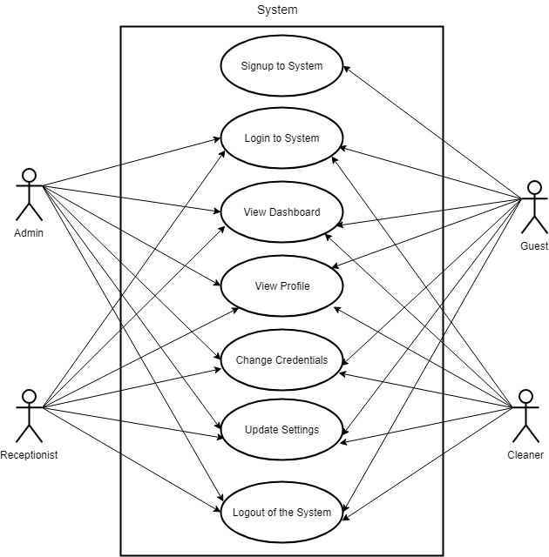

#### Use Case – Admin

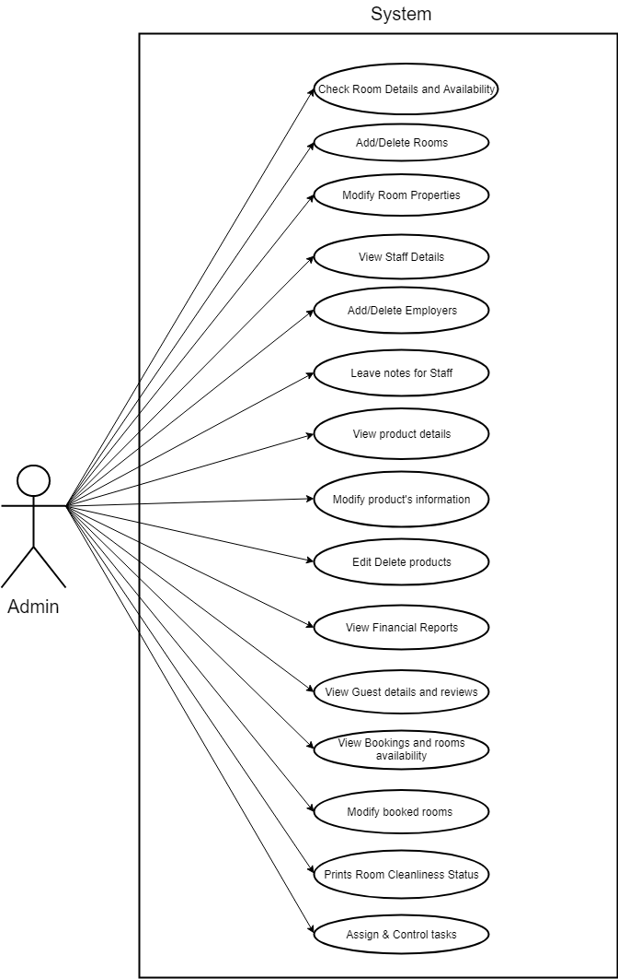

#### Use Case – Receptionist & Guest

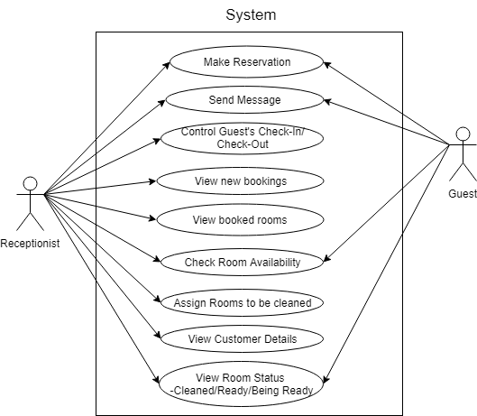

#### Use Case – Cleaner

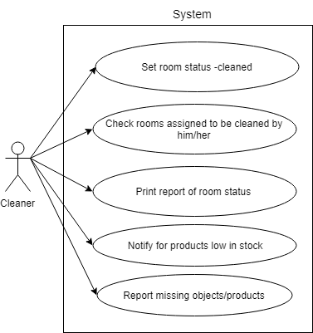

#### Use Case – General (All Users)

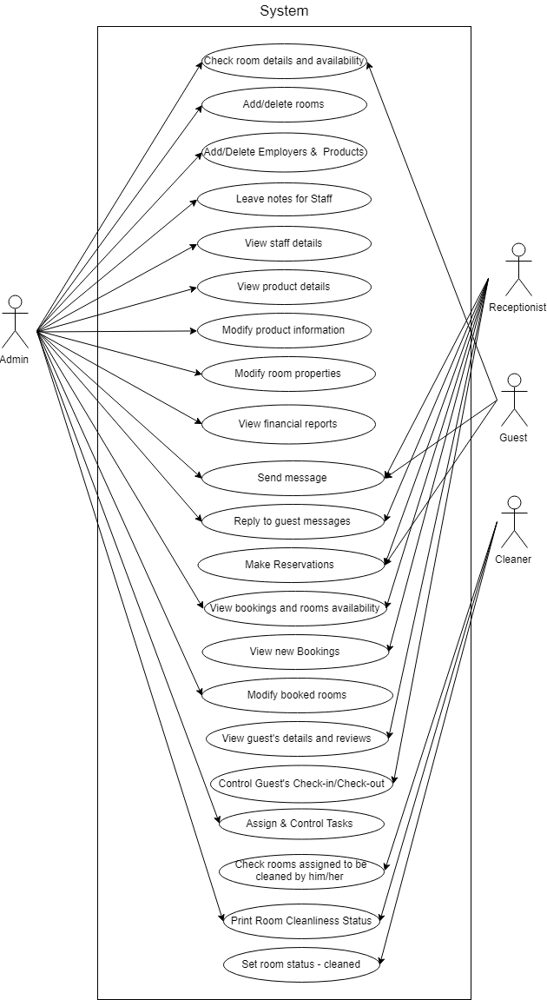

### Activity Diagrams

Admin Dashboard Cleaner Activity

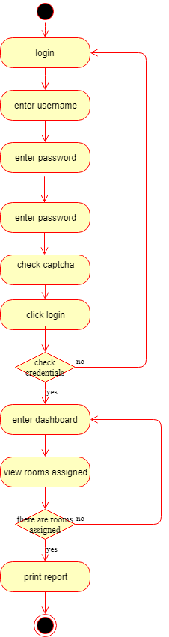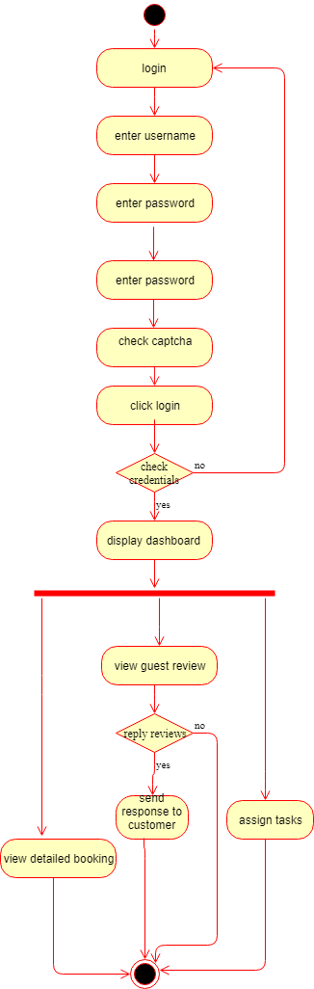

Employee Management

Booked rooms management

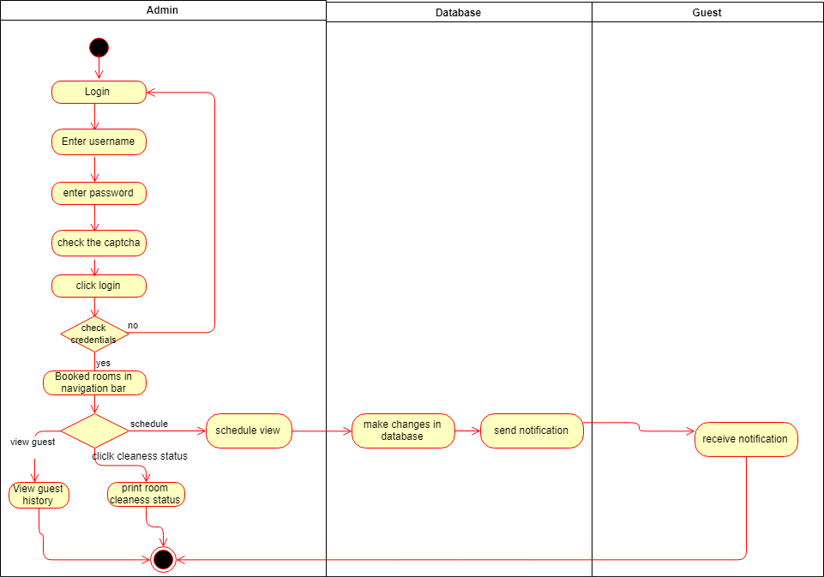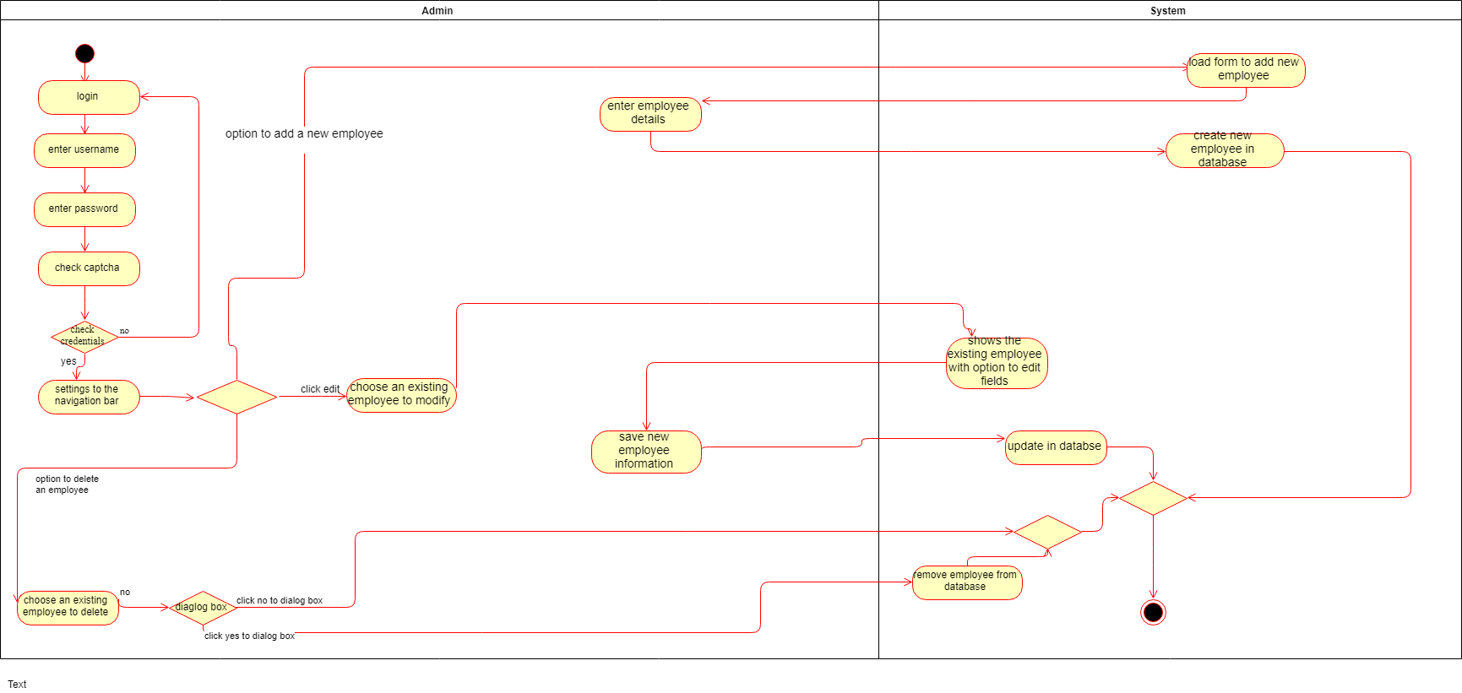

Guest Booking

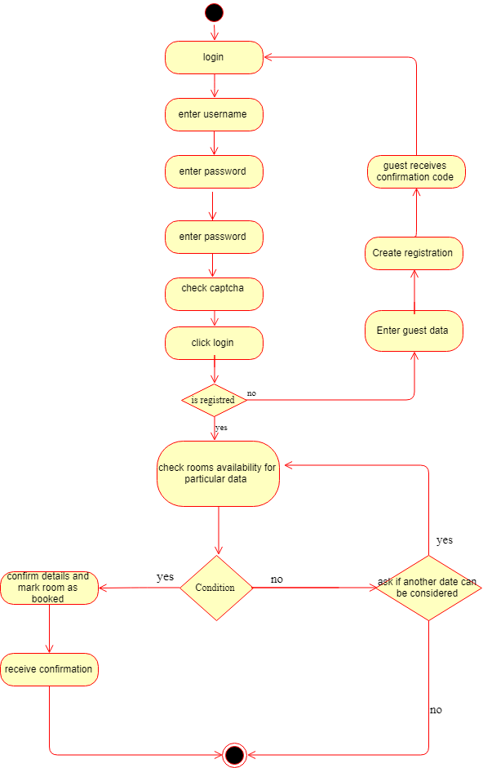

Inventory Management

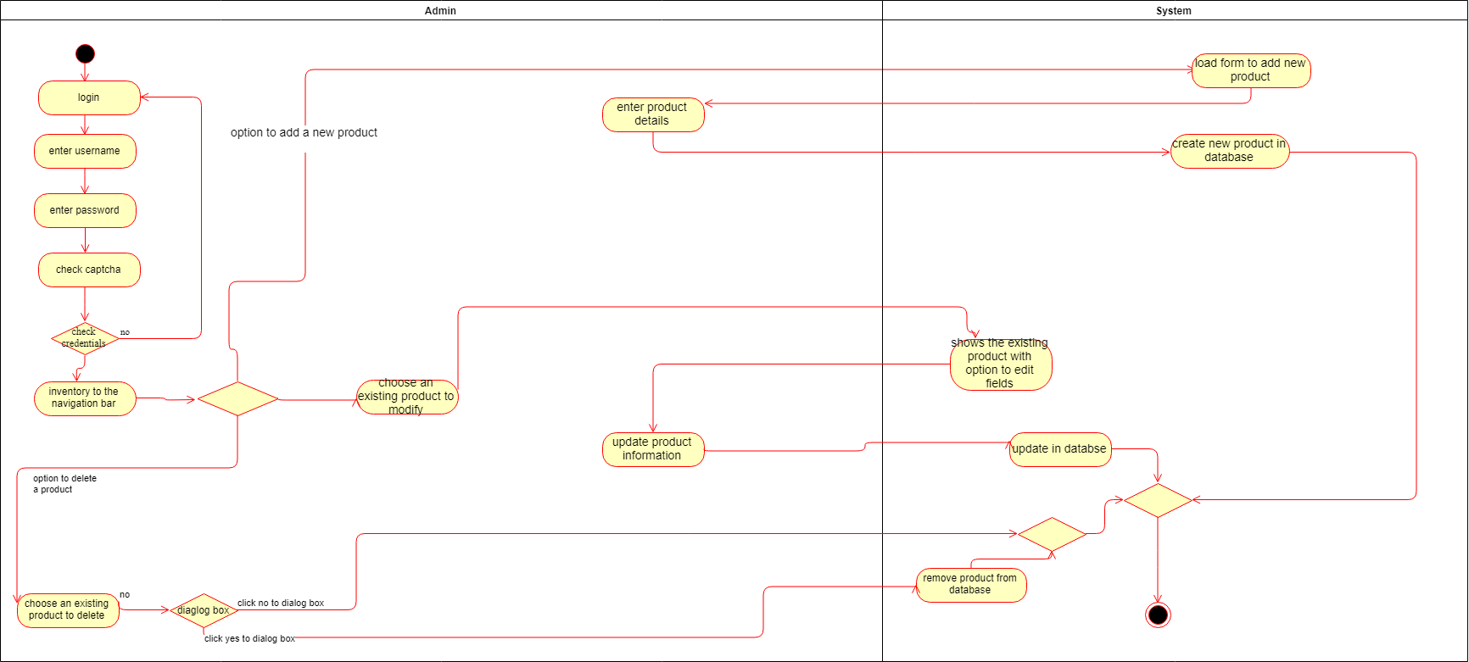

Receptionist Activity

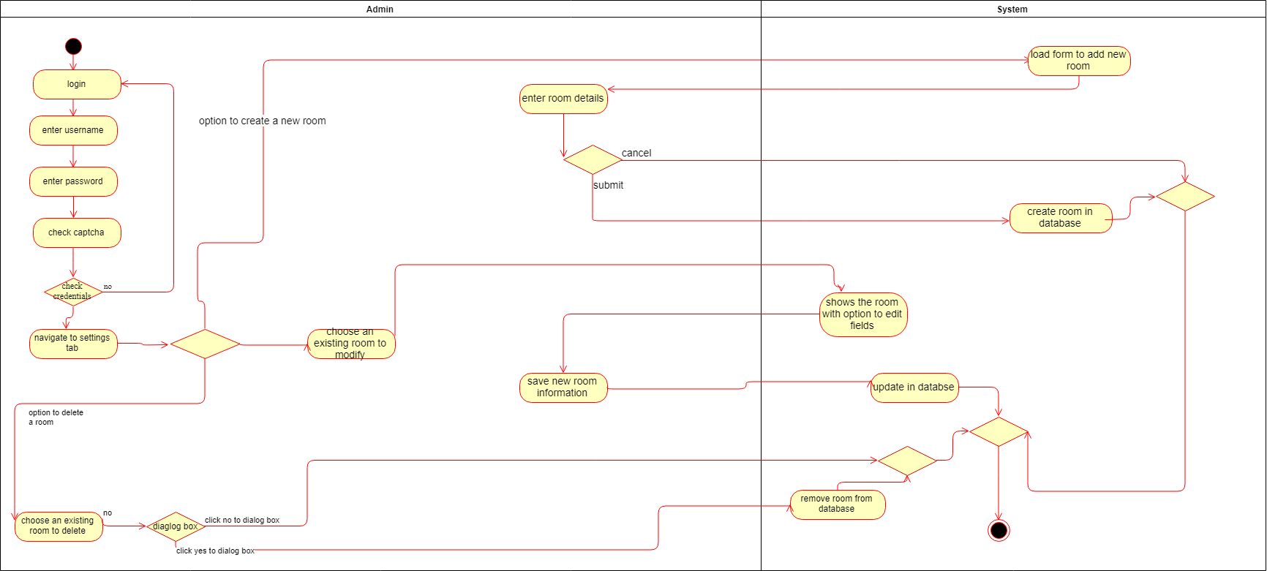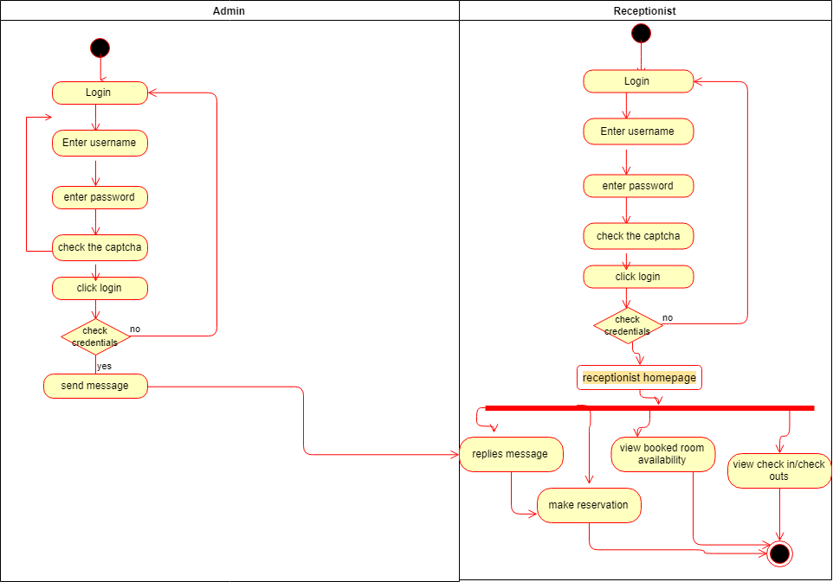

Receptionist Activity

Profile Management

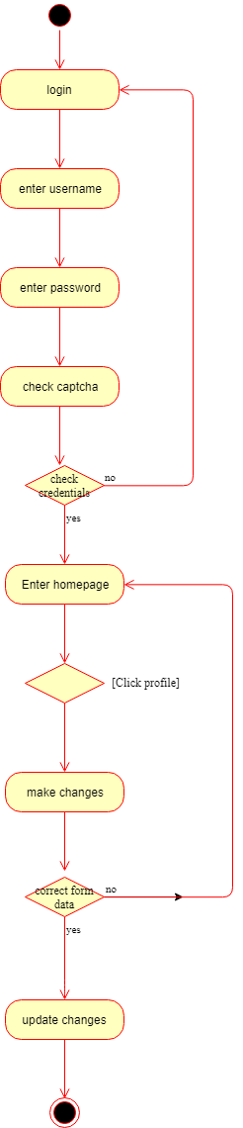

### State Diagrams

#### State Diagram – Admin

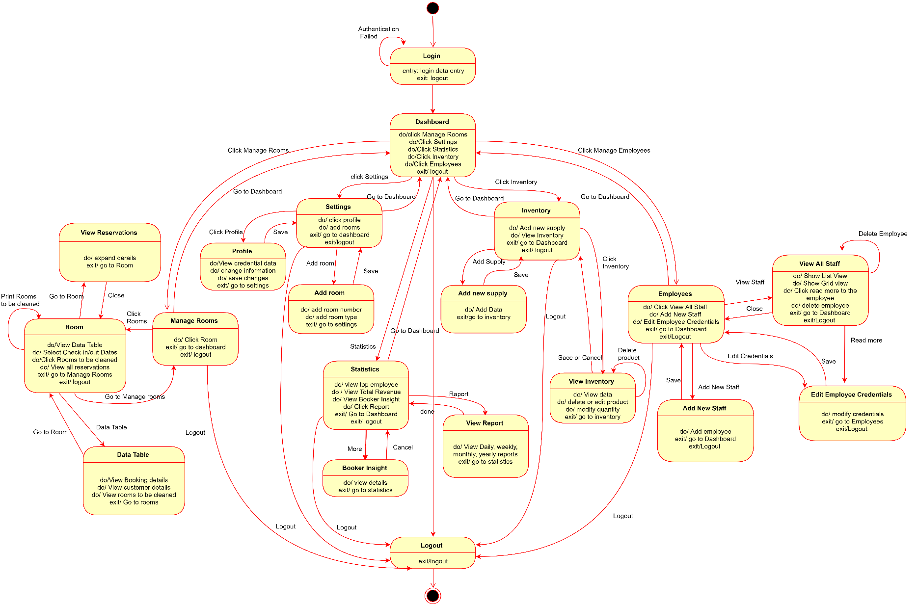

#### State Diagram – Receptionist

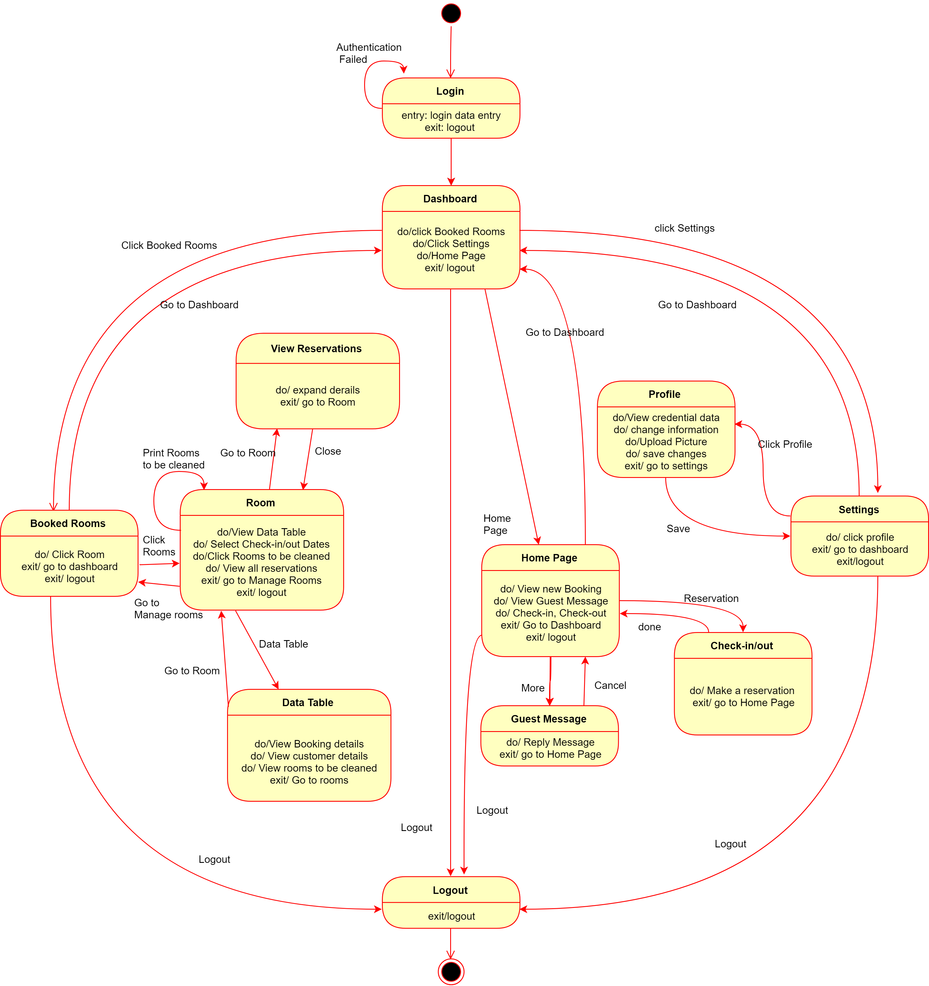

#### State Diagram – Customer

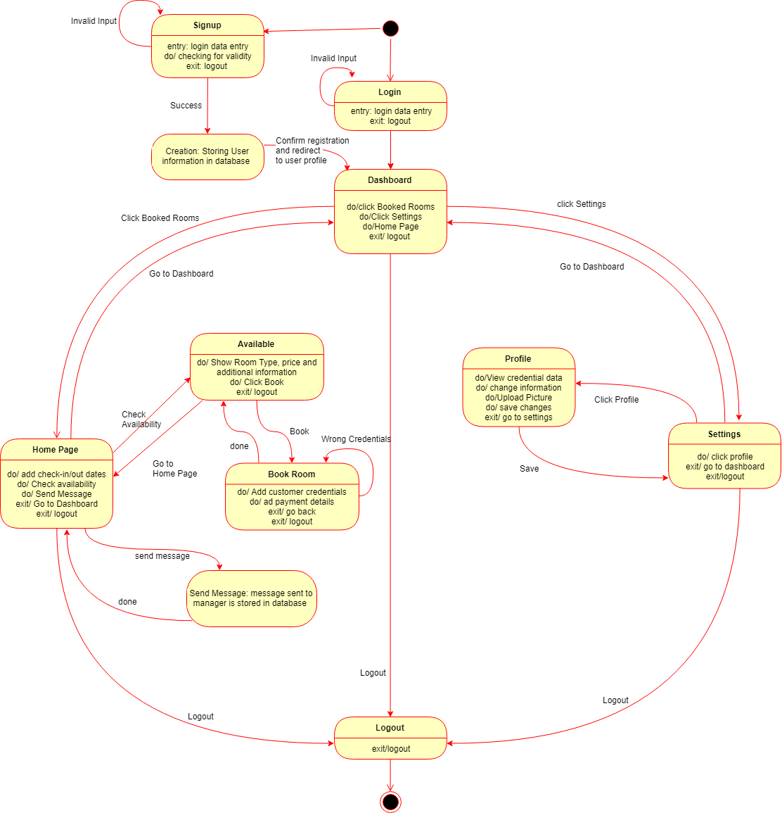

#### State Diagram – Cleaner

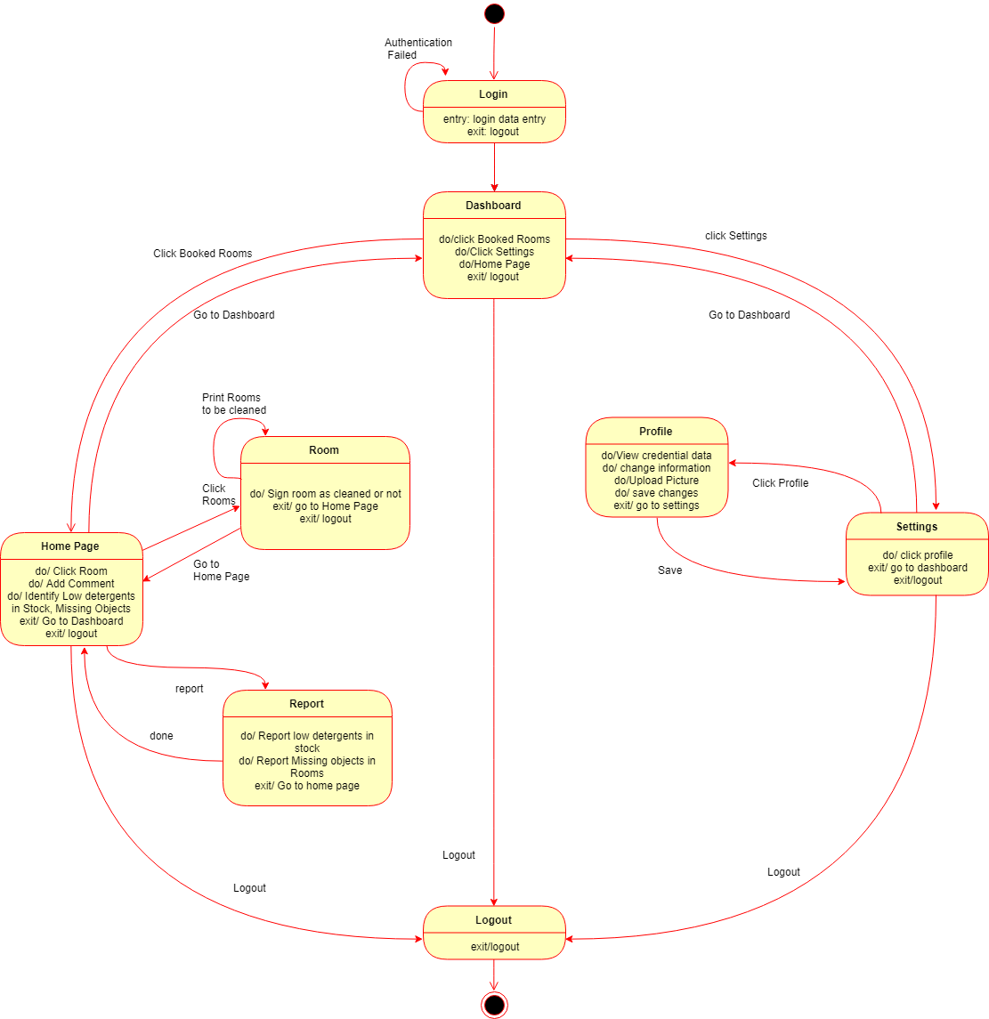

### Interaction Diagram

#### Sequence Diagram

##### Sequence Diagram – Authentication

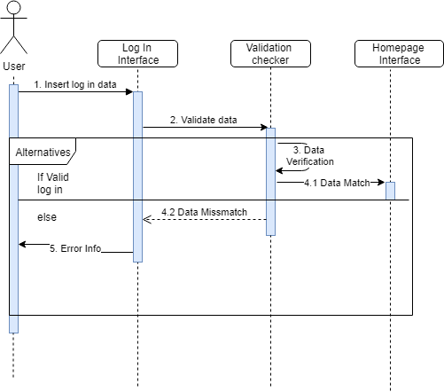

##### Sequence Diagram – Cleaning Process

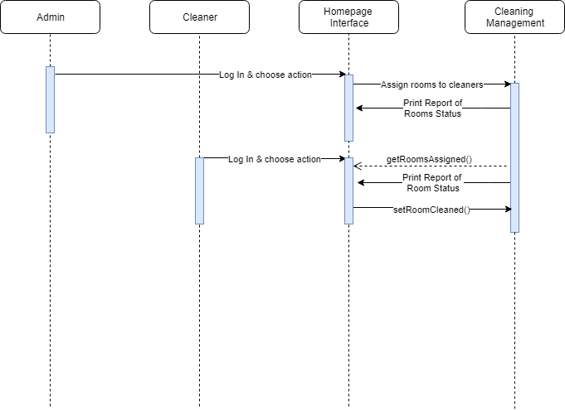

##### Sequence Diagram – Booking Process

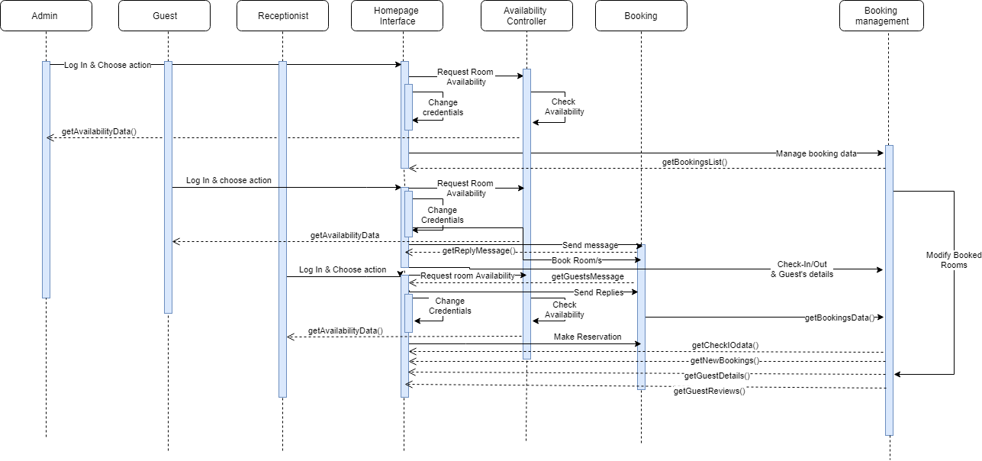

##### Sequence Diagram – Hotel Management

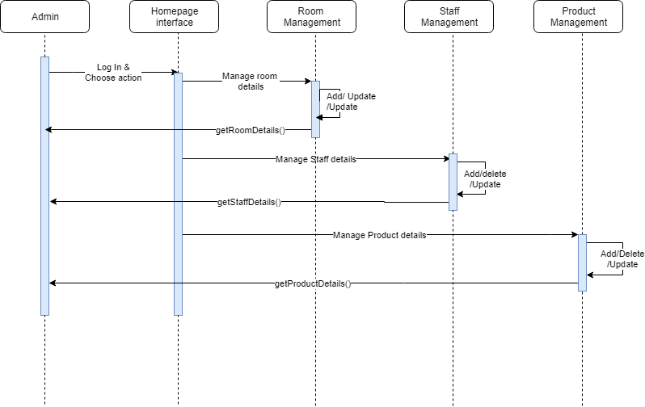

#### Collaboration Diagram

##### Bill-Customer-System

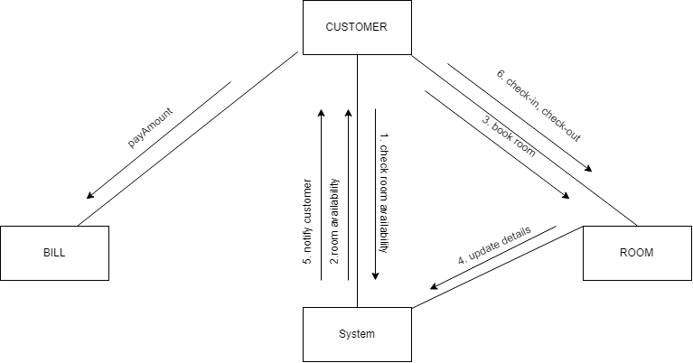

##### Cleaner Room Report

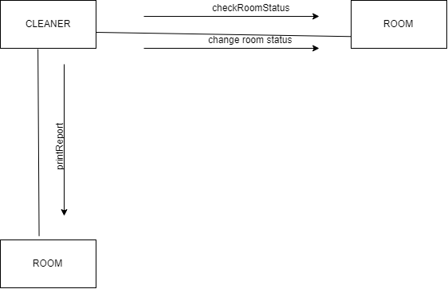

##### Dashboard – Admin – Room – Product – Staff

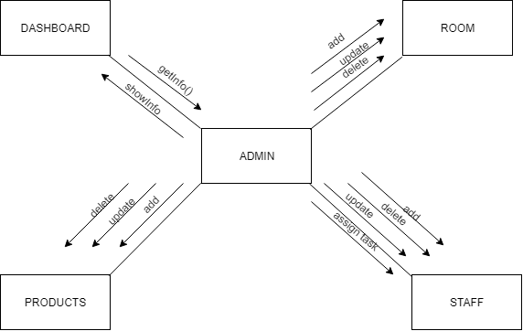

##### Guest – Message – Receptionist – Room

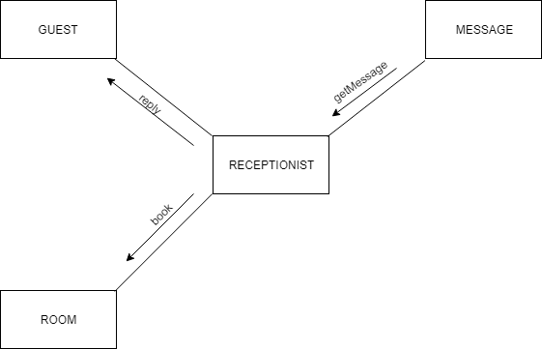

### Data Flow Diagram (DFD)

#### DFD – Level 0

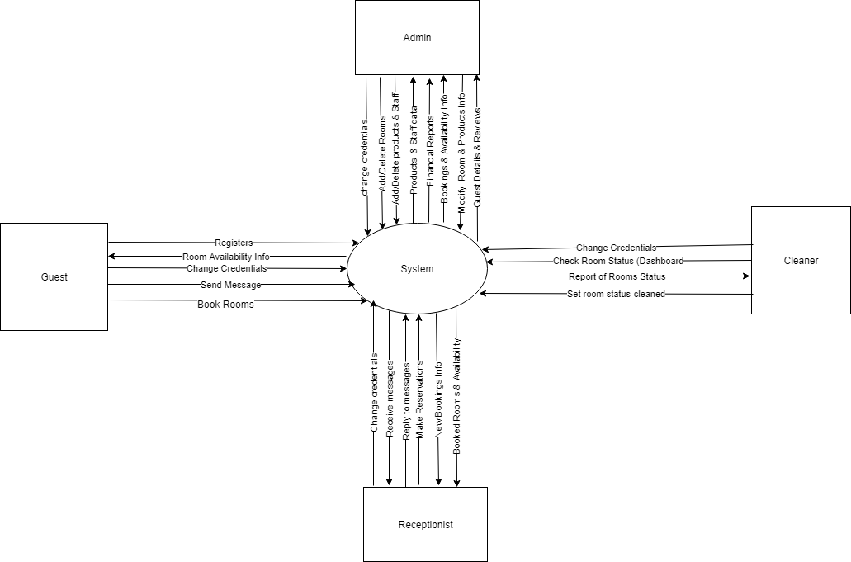

#### DFD – Level 1

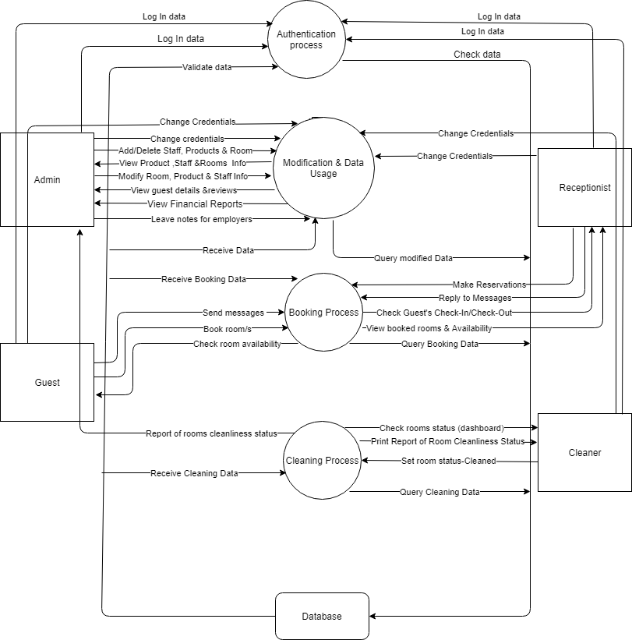

#### DFD – Level 2

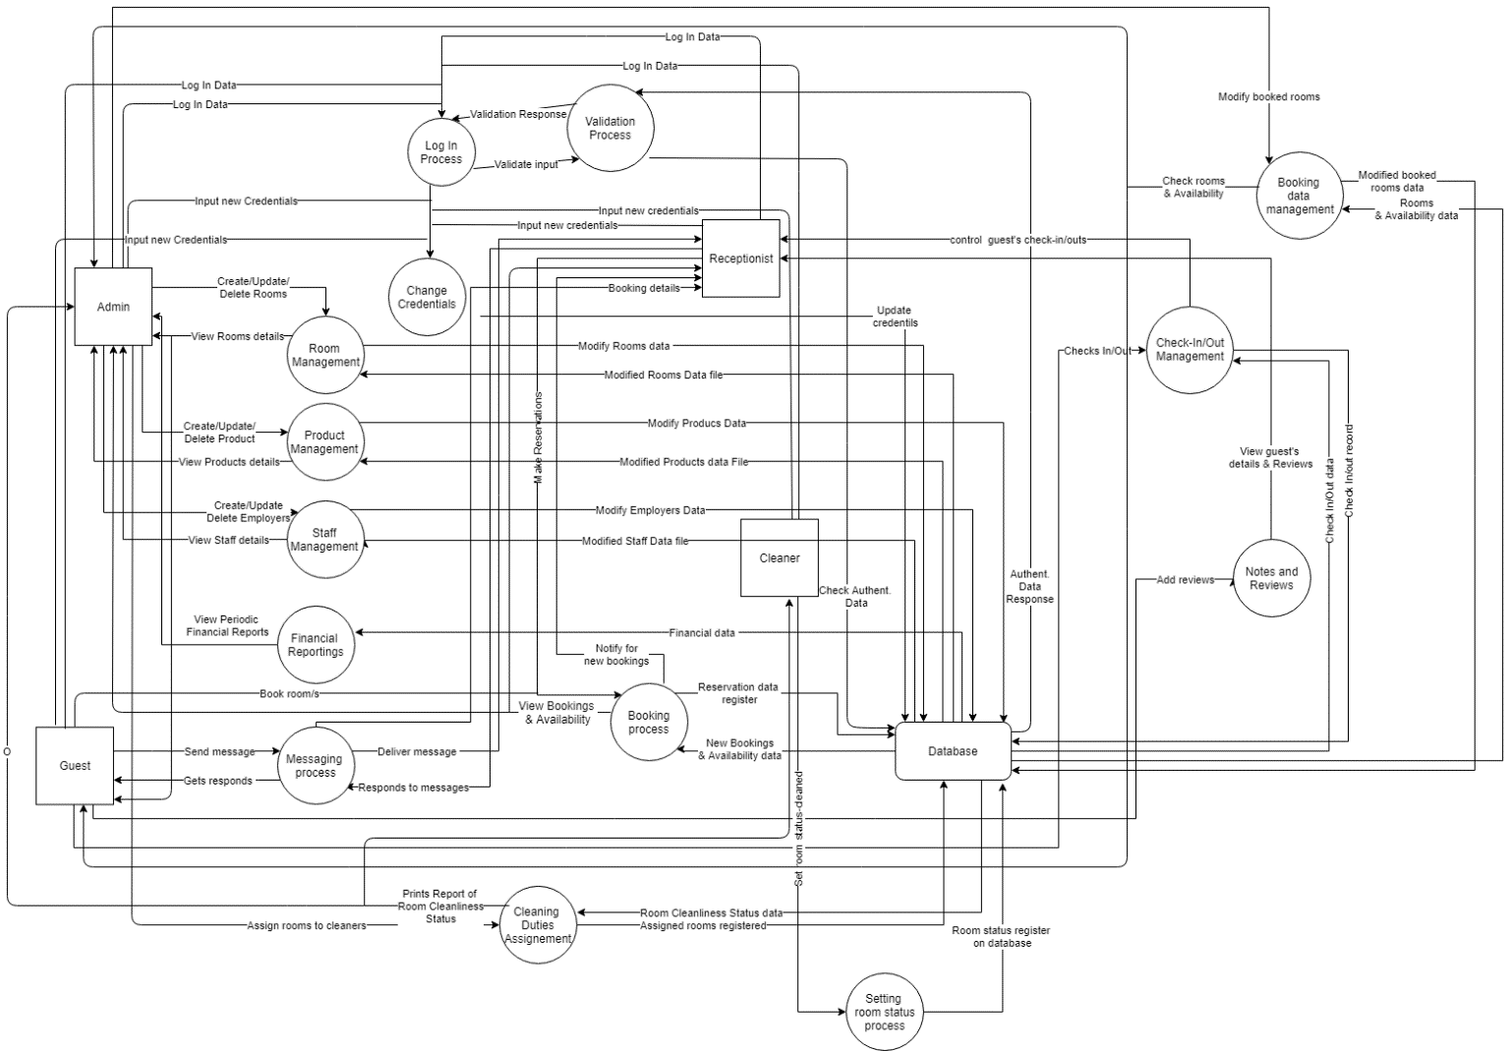

### Entity Relation

#### ER - Diagram with Attributes

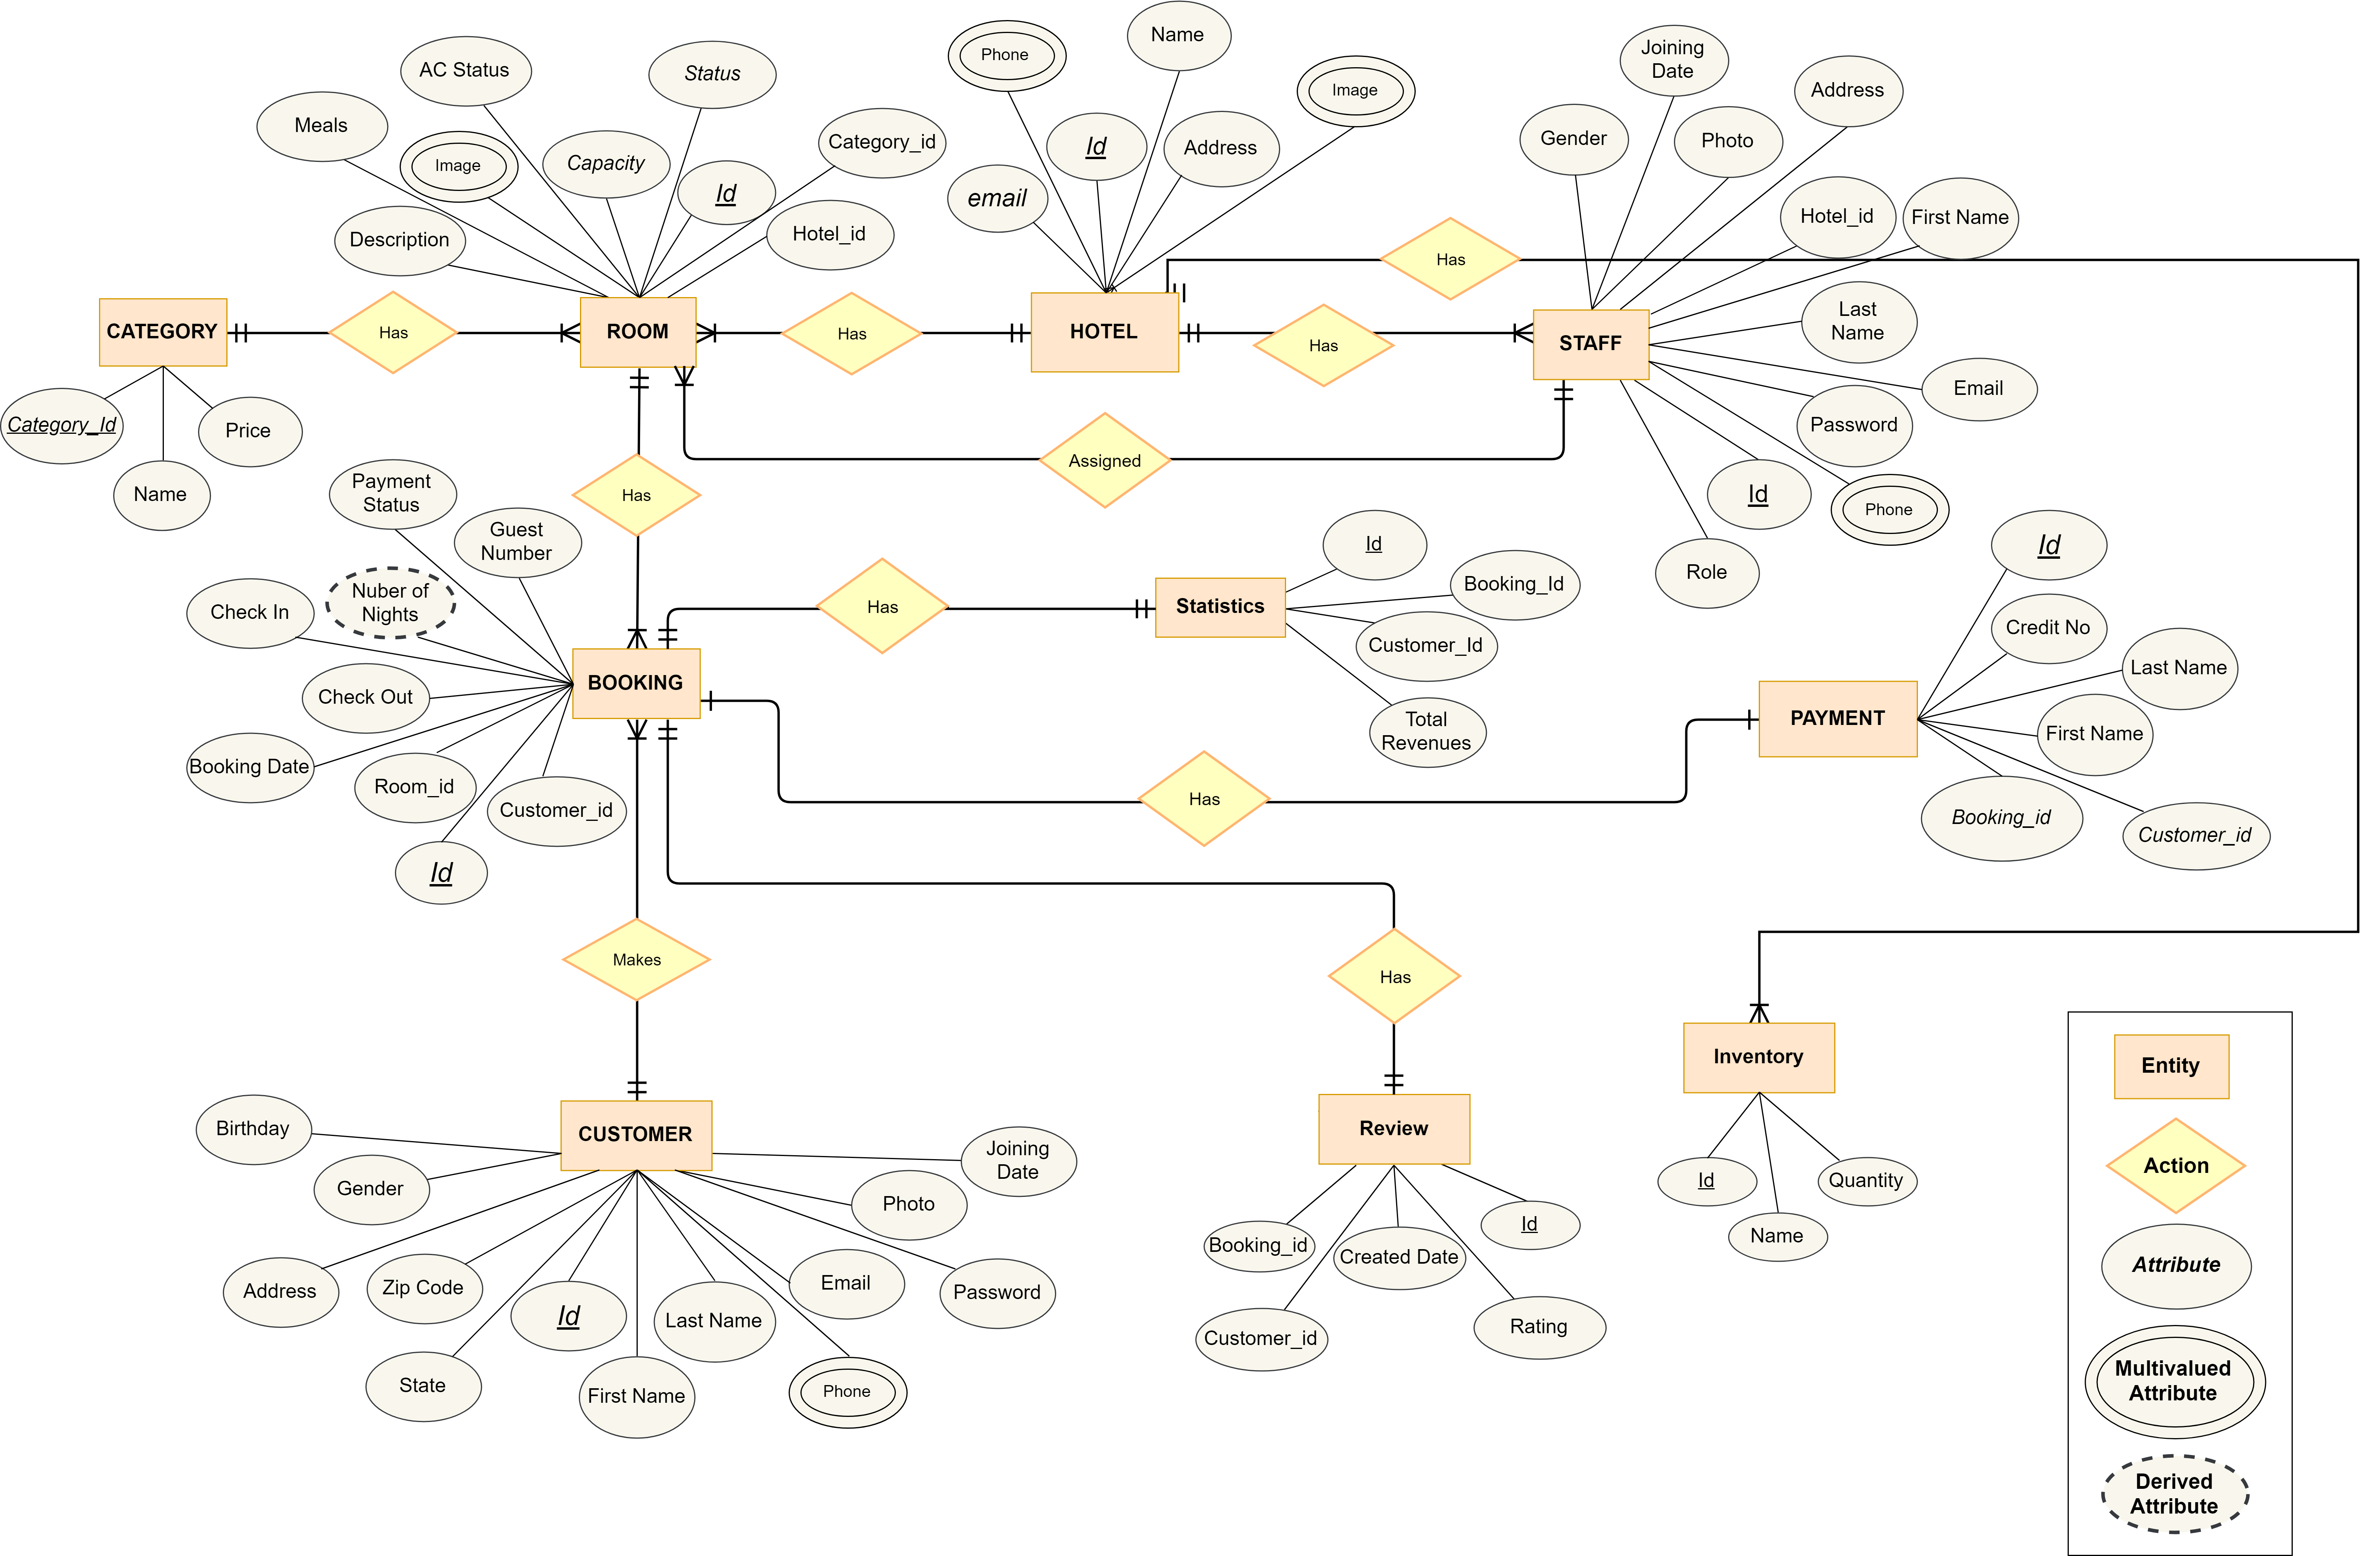

#### Database Schema Design

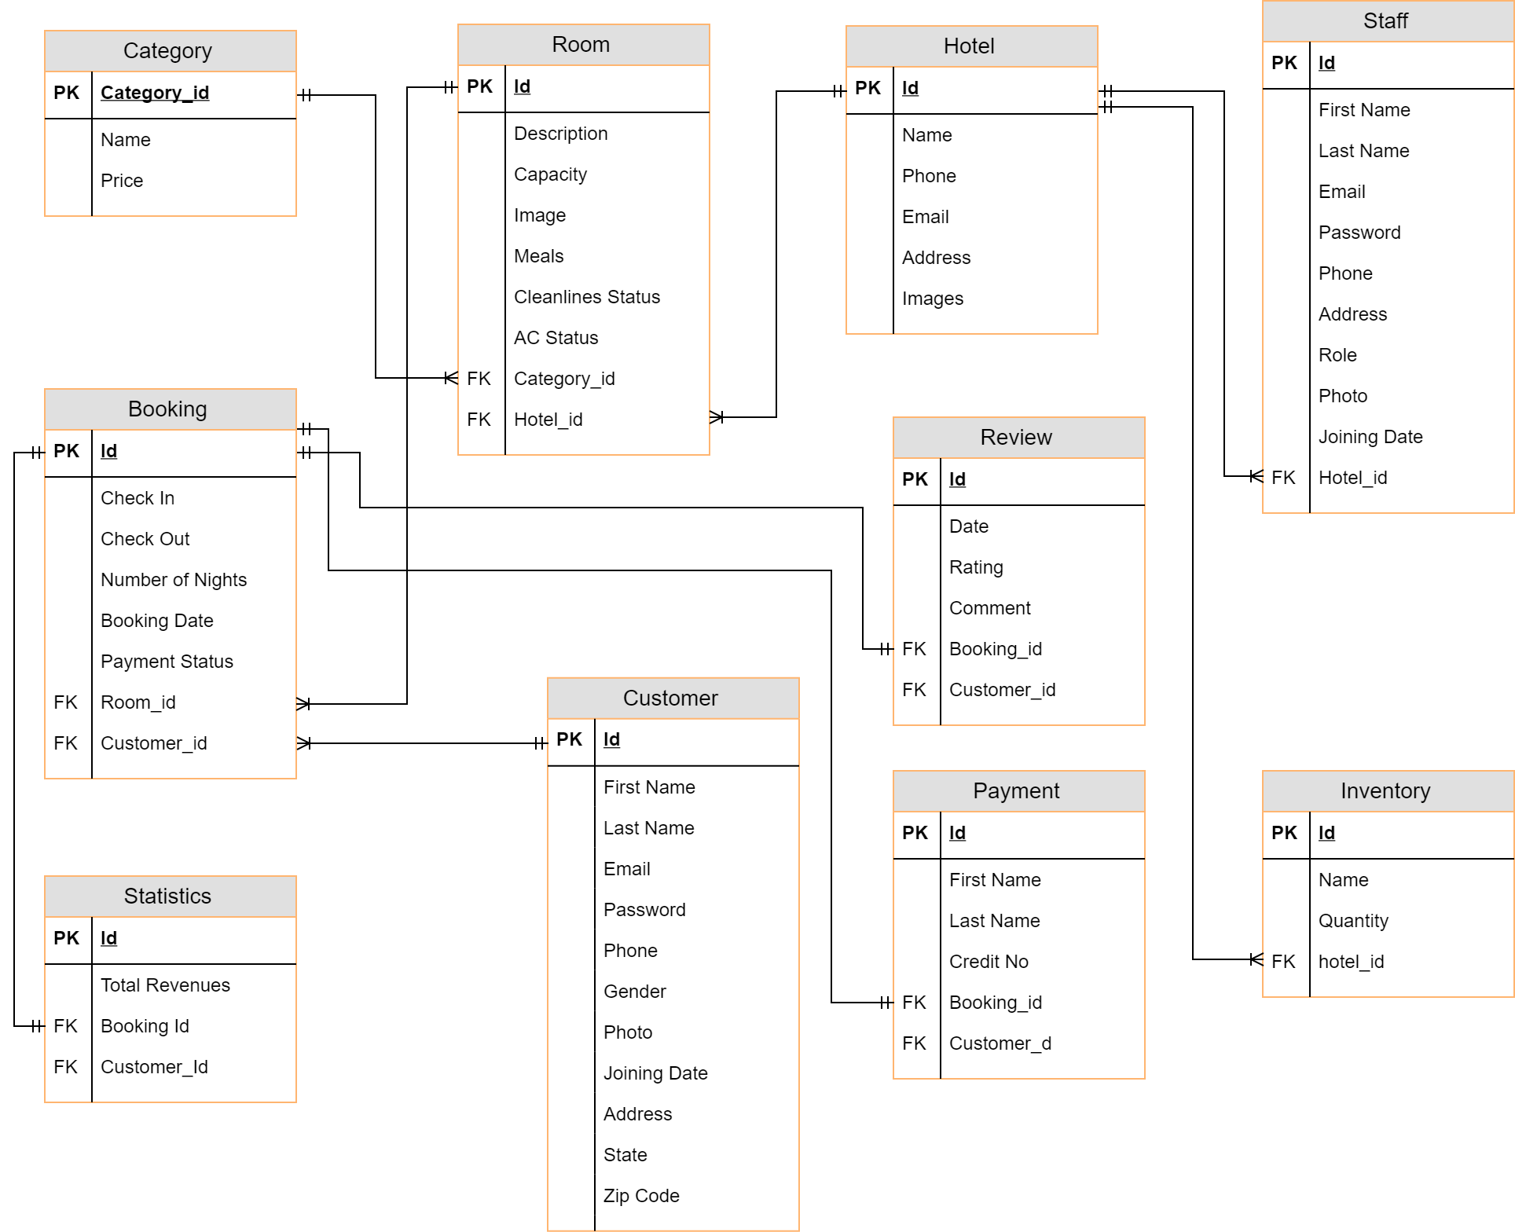

## Structural Diagrams

### Class Diagram

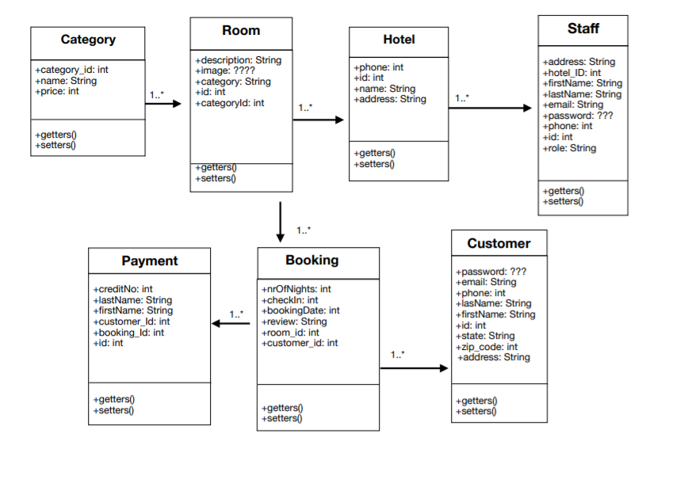

### Extended Class Diagram

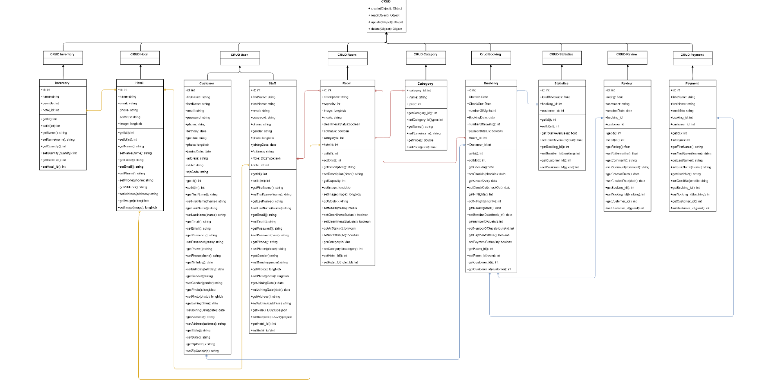

### Object Diagram

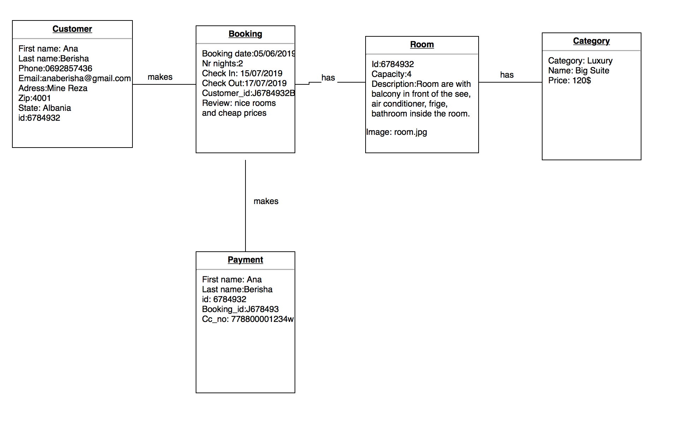

### Component Diagram

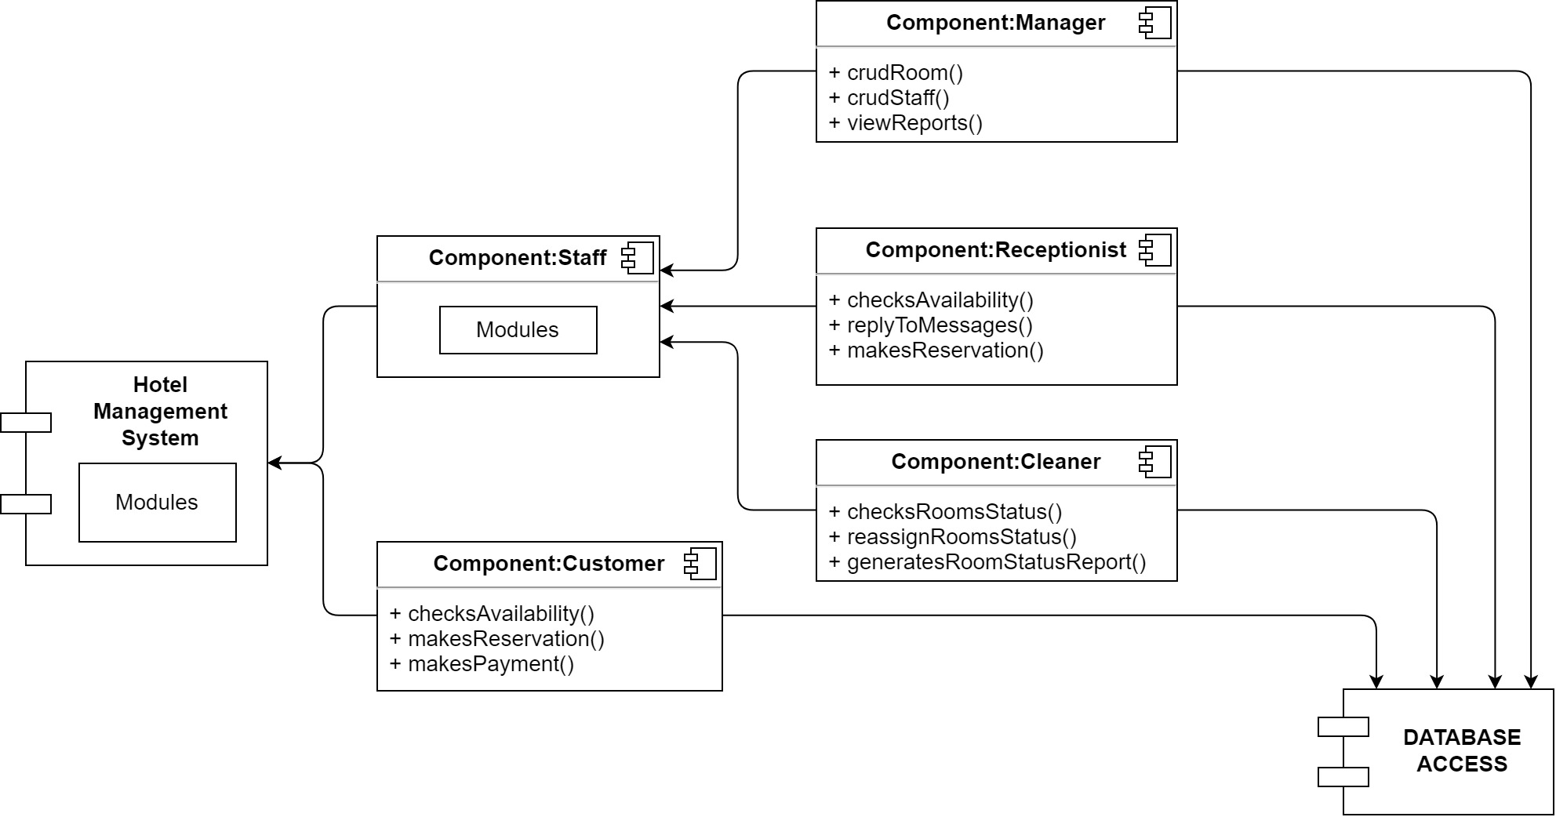

### Deployment Diagram

